Brass fasteners from HPC
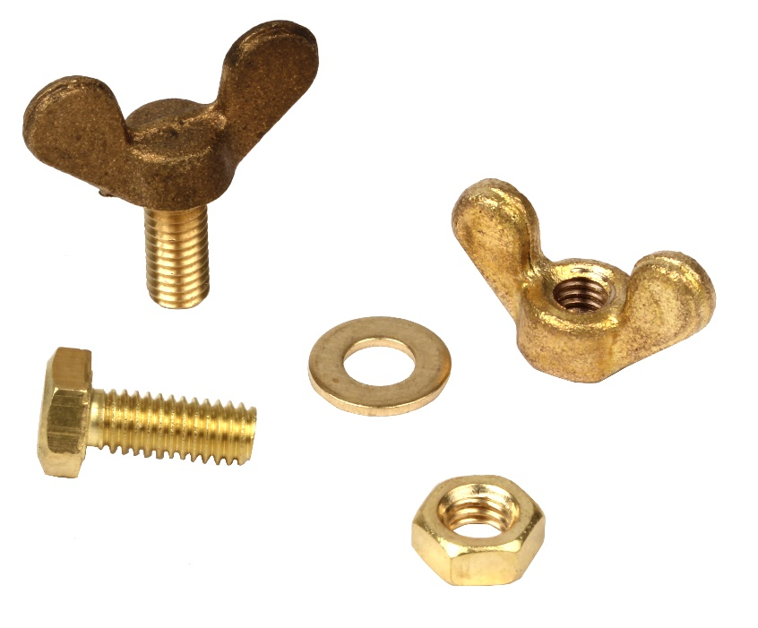

Engrenages HPC has extended its already extensive range of steel and stainless-steel fasteners with a full range of brass screws, washers and nuts. In addition to not suffering from corrosion, they have the advantage of being aesthetically pleasing.
This new family includes many different fastening elements:
- Hexagonal head screws (DIN933)
- Hexagonal nut (DIN934)
- Wing nuts (DIN315)
- Wing screws (DIN316)
- Flat washers (DIN125)

